

INTEGRATION SERVICE

DETAIL DESIGN

© The Marlborough Stirling Canada 2007

Version: 0.4

August 17, 2007

CONTENTS
Revision History iii
1 Introduction 1
1.1 Scope 1
1.2 Audience 1
1.3 References 1
2 Detailed Design 2
2.1 Common Data Interface (CDI) Schema 3
2.1.1 Promoted Property Schema 5
2.2 Transformation 5
2.3 Configuration Manager 6
2.4 BizTalk Orchestration 8
2.4.1 Exception Handling 11
2.4.2 Message and Variable Types 12
2.4.3 Send Ports 12
2.5 Security 13
2.6 Service Connector 14
3 Extended Features 15
3.1 Event Driven Custom Publish/Subscribe Mechanism (MwLink) 15
3.1.1 Database Structure 16
3.1.2 SQL Adapter Schemas 18
3.1.3 Configuration Sections 19
3.1.4 Exception Handling 20
3.2 Auditing 20
3.2.1 Database Table 20
3.2.2 Orchestration 21
3.2.3 SQL adapter send port 21
3.3 Recipient List Pattern 21
4 BizTalk Performance Settings 24
4.1 CLR Hosting Thread Values for the Host 24
4.2 HTTP and SOAP Adapter Performance 24
APPENDIX A – CDI Schema 26

Revision History

Date | Version | Description | Author | Reviewed By
Dec 05, 2006 | 0.1 | Initial Draft | Nagesh Chawla
Feb 20, 2007 | 0.2 | Modified configuration details | Nagesh Chawla
Aug 13, 2007 | 0.3 | Added extended features | Nagesh Chawla
Aug 17, 2007 | 0.4 | Added performance settings | Nagesh Chawla

Introduction

This document provides a more detailed archiectural design of major components of the high level architecture envisioned for the Integration Service. For the first phase of the Integration Service development, this detailed design will focus on the AIG specific requirements and consumption of AIG published service. However, more advanced features will be added as the Service is evolved while implementing various integrations.

The high level architectural components as specified in the “Integration Service Solution Architecture” document are:

- Common Data Interface (input schema)
- AIG Schema
- Transformation mapping
- Configuration Manager
- BizTalk Orchestration
- Authentication
- Service Connector

While the above component make-up the general framwork for the messaging bus architecture, the detail design is not limited just these components. The design will involve other components as advanced features.

Scope
The scope of this document focuses messaging framework of the Service.

Audience
The audiences of this document are:
Systems Analysts: MorWEB, Omiga and Optimus system analysts.
Reviewers: Product management.

References
  - Integration Service High Level Solution Architecture

Detailed Design

This section presents detailed design of major architectural components to implement the use cases. The high level architecture discussed in the architectural document is presented in the figure below:

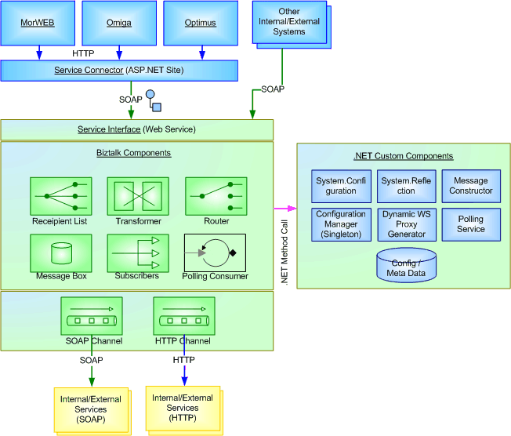

Figure 1: High Level Architecture for Integration Service

The functional activity of overall messaging mechanism involved in servicing a request is illustrated by a scenario where a “Request MI” message is sent to AIG service, as shown in the following figure. The activities are:

- A user invokes a request from an external/internal (ex: MorWEB) application.
- The application compiles necessary data required to process the request in CDI format and posts to the Service Connector using XMLHTTP protocol. If the application is external system, it would post data directly to the Service.
- Service Connector loads XML data into CDI schema object, which is the input type for the service and posts the object to the service.
- The service retrieves configuration data, determines the recipient of the message, transforms the message and sends to destination or recipient service interface using SOAP adapter.
- The recipient processes the request and returns a response.
- The Integration Service returns the response to the user via the Service Connector and MorWEB for further processing.
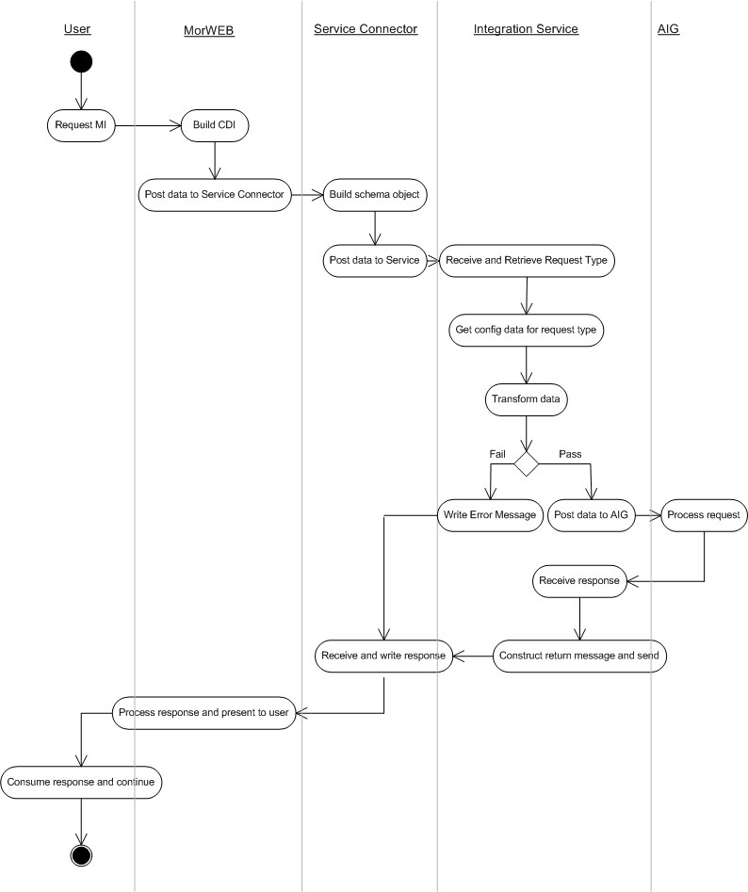
Figure 2: Functional Activity of Overall Messaging

The specific details of the Service Connector and major components of the Integration Service involved in achieving the above activity are discussed in the following sections.

Common Data Interface (CDI) Schema
CDI is a unified data interface across all request types for the Integration Service. The input to the service should conform to this schema, the first draft of which is provided in the Appendix A. The goal of the CDI is to facilitate a common data structure across all systems, which could evolve as an industry standard language specification, at least within MSC.

The major sections of CDI are as follows:
- Clipboard
- Context
- Request
  - Comment
  - Errors
- Application Data

Clipboard is a root element in the CDI and contains the namespace http://mscanada.com

Context describes the context within which the domain data instance is created and used. This section specifies application name, language, date time and user id etc.

Request describes what type of request is being made by the system. This section amongst other data contains the following attributes:

requestId: a guid value to identify the request uniquely. The request id will also enable us to correlate an asynchronous response to the original request at later stage.

provider: provider of the service being invoked by the Integration Service. For example, AIG is a provider which provides services like RequestMI and RequestPremium. If provider has different environments, then the provider value could concatenate the environment name with provider name. For example, provider AIGUAT specifies end point to be used is UAT within provider AIG.

serviceType: an external service being invoked by the Integration Service.

recipient: a target recipient of the message being processed by the Integration Service instance. This is the end point for the message.

source: source application that the message originated from. For example, MorWEB is the Premium requestor and sends message to AIG via Integration Service. If there are different environments for given source application, the environment id is concatenated with source application name. For example, MorWEBIdaho specifies the source application is MorWEB in Idaho environment.

The values for these attributes are set in the source application when the message in CDI format is built. To configure the values dynamically, MorWEB provides TPinterface database table.

Comment contains any comments regarding request or response.

Errors contain a collection of error nodes to communicate any errors that are encountered.

Application Data contains a cross section of domain data. IN case of a response this node can also be mapped to response data and return to the calling application.

The CDI schema needs to be reviewed and developed further during development phase.

Promoted Property Schema
Promoted properties enable BizTalk Server components to access key data elements of a schema. By promoting key elements of a schema, the BizTalk components can access incoming message data without even loading it into the memory. The key data elements help navigate through BizTalk orchestration and routing. Further, the promoted properties can be used in filter conditions when multiple physical send ports are configured.

The data elements that will be promoted from the CDI schema are serviceType, source and provider attributes of request node. The provider and serviceType values should match section name and serviceType element in the configuration file. This will allow easy retrieval of configuration data and use the data in orchestration. The orchestration will retrieve the message related configuration data using Configuration Service, which is discussed later in this document. Further details regarding promoting these attributes are discussed in the Transformation section

Transformation
When integrating an external system, usually data is sent in a format which is required by the external system, which could be different from the request origination system schema. Therefore the data needs to be transformed from request originating system schema to recpient system schema. BizTalk provides schema mapping functionality to transform data structures.

To achieve this transformation:
- Create a project named “Schemas” within MSC namespace using BizTalk project template. Keep all schemas for the Integration Service within this project.
- Open CDI schema.
- Promote serviceType, provider and source attributes of the request node using Quick Promotion option.
- Create a BizTalk map (.btm file) using map editor in BizTalk from CDI schema as the source and recipient system schema as the destination. Name it CDI_[recipient_system_name].btm.
- Create a strong name key file. All components must be signed and installed in GAC, to be used by BizTalk runtime.
- Change project properties to include the strong name key file information.
- Compile the project.
- Install the project in GAC using gacutil.
- Once installed in GAC, copy the publicKeyToken of the assembly and update “requestMapType” attribute of serviceType element in the configuration file. This will allow orchestration ot dynamically load the mapping assembly at runtime.

Configuration Manager
The Integrationn Service orchestration depends upon some basic configuration data that instructs message semantics. The following table shows the configuration data needed to forward a message to a destination.

<?xml version="1.0" encoding="utf-8"?>
<configuration>
<configSections>
<section name="AIGUAT" type="MSC.ConfigurationService.messageConfig,MSC.ConfigurationService"/>
<section name="MorWEBIdaho" type="MSC.ConfigurationService.messageConfig,MSC.ConfigurationService"/>
<section name="GMAC" type="MSC.ConfigurationService.messageConfig,MSC.ConfigurationService"/>
</configSections>
< AIGUAT description="" type="provider">
<serviceTypeList>
<serviceType name="RequestMI" direction="outbound" aggregateResponse="false">
<recipientList>
<recipient name="" url="" userId="" password="" protocol="" assembly=""
operation="" operationType="sync|async"
recipientDomain="internal|external" requestMapType="" responseMapType="" />
</recipientList>
</serviceType>
<serviceType name="RequestPremium" direction="outbound" aggregateResponse="false">
<recipientList>
<recipient name="" url="" userId="" password="" protocol="" assembly=""
operation="" operationType="sync|async"
recipientDomain="internal|external" requestMapType="" responseMapType="" />
</recipientList>
</serviceType>
</serviceTypeList>
</AIGUAT >
<MorWEBIdaho>
<serviceTypeList>
<serviceType name="ReceiveRiskUW" direction="inbound" aggregateResponse="false">
<recipientList>
<recipient name="" url="" userId="" password="" protocol="" assembly=""
operation="" operationType="sync|async"
recipientDomain="internal|external" requestMapType="" responseMapType="" />
</recipientList>
</serviceType>
</serviceTypeList>
</MorWEBIdaho >
<GMAC>
<serviceTypeList>
<serviceType name="ReceiveRiskUW" direction="inbound" aggregateResponse="false">
<recipientList>
<recipient name="" url="" userId="" password="" protocol="" assembly=""
operation="" operationType="sync|async"
recipientDomain="internal|external" requestMapType="" responseMapType="" />
</recipientList>
</serviceType>
</serviceTypeList>
</GMAC>
</configuration>

To facilitate mangement of this configuration data, implementation will leverage .NET 2.0 System classes within Configuration namespace. It will use XML file storage provider to specify the config data and the XML Serializer for data transformation. Implmentation of this configurtation management consists of custom and derived classes that make up a Configuration Service. The goal is to evolve this re-usable configutration service for all MSC products eventually.

The following class diagram shows the initial implementation of the Configuration Service.

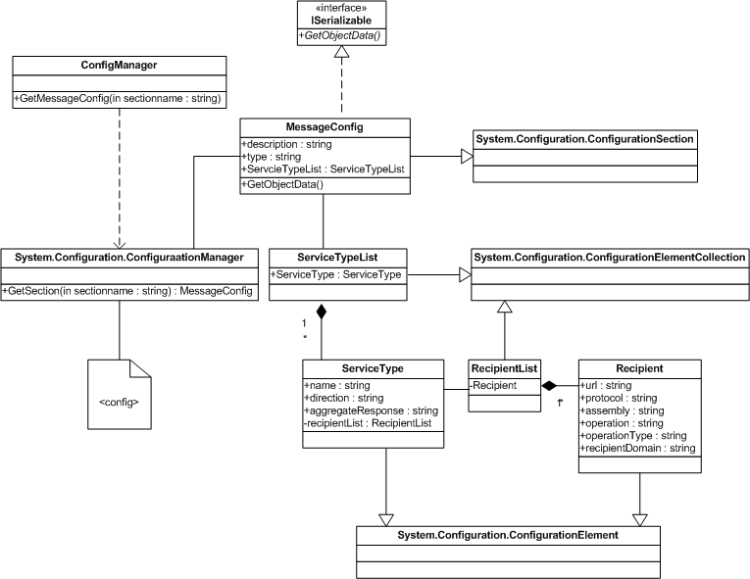

Figure 3: Configuration Service Static View

.NET 2.0 Configuration namespace provides ConfigurationSection class that handles each section specified within the configuration file. The custom class MessageConfig is inherited from the ConfigurationSection class and provides deserialized instance of section data. The MessageConfig class uses ServiceTypeList class that is inherited from ConfigurationElementCollection class. This class represents all services or service types implemented by a given provider. From the Integration Service view point, a service type may represent other processes that may have to be completed for the current message or request by calling other services or processes, which are represented by a list of recipients. These recipients are listed by RecipientList class that is inherited from ConfigurationElementCollection. RecipientList class represents collections of recipients specified for a given message. The RecipientList class uses Recipient that is inherited from ConfigurationElement class and represents each recipient’s meta data. Note that the MessageConfig class needs to implement ISerializable interfacae in order to serialize between CLR and BizTalk runtime processes.

The client object that needs to consume configuration data invokes ConfigManager and calls GetMessageConfig method. This class uses ConfigurationManager class, which implements complete XML serialization plumbing, to retrieve configuration data and return MessageConfig class.

The specification of GetMessageConfig method of ConfigManager is as follows:
- Declare a variable of MessageConfig class type.
- Call ConfigurationManager’s GetSection method while passing section name.

The Configuration Service is extensible. As long as the implementation of MessageConfig conforms to the schema of message section (XML elements and attributes), any number of sections can be specified and the Configuration Service can be used to retrieve that data.

BizTalk Orchestration
BizTalk orcehstration is the core of the Integration Service. The orchestration contains BizTalk components such as Expressions, Transformers, logical Ports, etc. The following sequence diagram illustrates how a message received by the Integration Service is processed using AIG integration scenario.

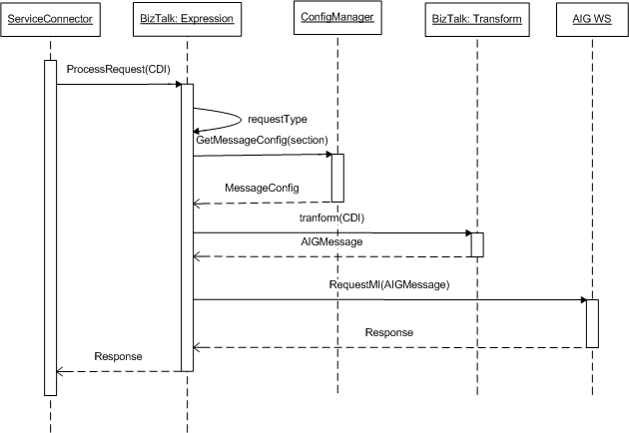

Figure 4: Messaging Mechnism in the Integration Service

The BizTalk orchestration will be published as a web service. This is further discusssed in this section below. Once the message is received by the service via web service interface, logic implemented within an Expression shape determines the provider for the request and service type. This is done by simply reading the values of promoted properties into a variable. Based on the service type, configuation data related to this request is retrieved using ConfigManager, which returns MessageConfig object. The object is captured into a variable declared within the orchestration for further consumption. The configuration data contains appropriate assembly information to be used to perform the transformation. Using this information, BizTalk tranformation is invoked to construct a message in recipient system schema. This message is then sent to AIG published web service via logical port. When response is received from the AIG web service, it is forwarded back to the Service Connector.

The following diagram illsutrates a sample implementation of BizTalk orchestration for the AIG specific use cases. This may be changed as required during actual development phase and may further be changed to accommodate more generic functionality during next phase of development to implement functions such as polling and persistent database. The intent of this diagram here is to facilitate design discussion around some of the key elements of the orchestration and to provide visual assistance in understanding the discussion.

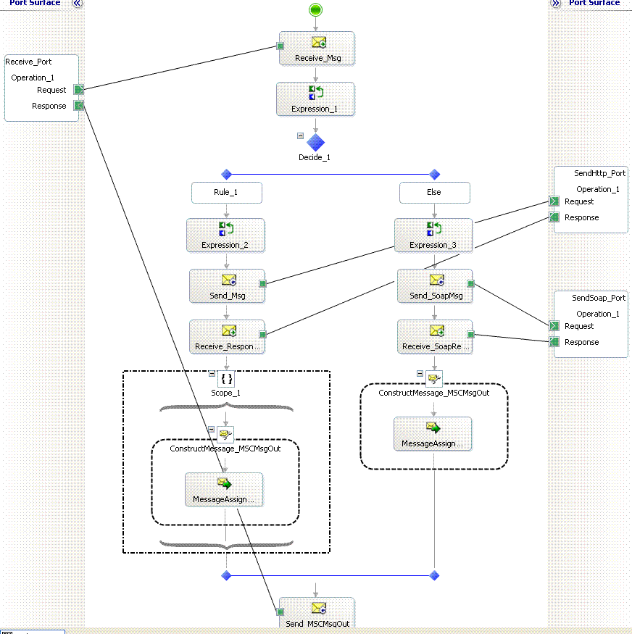
Figure 5: Sample Orchestration for AIG Use Cases

Receive_Port on the left hand side is a logical port and is an entry point for the orchestration. This logical port is mapped to a physical port at deployment time and attached to a specific adapter type such as HTTP, SOAP etc. In the AIG implementation, the orchestration will be published as a web service. Therefore the Receive_Port will be mapped to a SOAP adapter and web service URL using BizTalk Explorer. This port is a request and response type as the AIG call is synchronous.

Message received by the port is passed to Receive_Msg shape. The message type this shape receives conforms to CDI schema. Therefore message variable of type CDI schema is declared and assigned it to the shape. The message is then passed to an Expression shape where logic to retrieve configuration data is implemetned, as shown in the sequence diagram. Once the message configuration is determined, messgae is transformed to the target schema using BizTalk transformation map. This is achievedd using .NET reflection to load BizTalk map assembly and transform.

A decision shape helps route the transformed message based on a tagret protocol information. In this initial implemetnation, the orchestration will support HTTP and SOAP protocols. Within each decision branch, another expression shape is used to assign routing protocol specific information to the message dynamically, such as assembly of web service proxy, method name etc. A send shape, Send_SoapMsg, sends message to SendSoap_Port logical port. The logical port is a request-response type. This logical port is directly bound BizTalk message box. This enables publish-subscribe mechanism. All out going messages are published to BizTalk message box. At deployment time, multiple physical send ports (subscribers) can be implemetned to subscribe messages from message box and send them to their recipients. This is achieved by implementing filter conditions on the send port using promoted properties within BizTalk Explorer. The following diagram illustrates this mechanism:

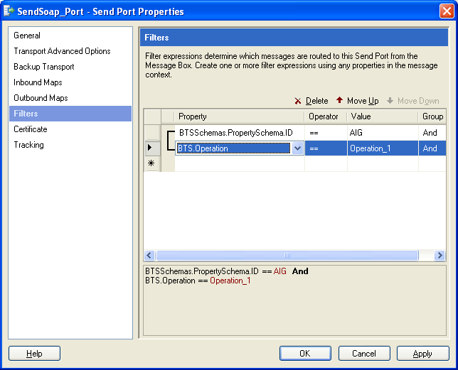

Figure 6: Filter Conditions on Physical Send Port in BizTalk Explorer

The response is received by another receive shape and is passed to a Message Constructor to construct response message going back to the Service Connector.

Exception Handling
All exceptionos are caught using an atomic scope in BizTalk. The CDI schema contains “error” node collection. When an exception occurs, the incoming message in CDI format is updated with exception details and sent back to caller. The calling application is responsible for reacting to the exception, correcting the request information and re-sending the request if needed.

To implement exception handling:

- Drop an atomic scope shape in the orchestration.
- Create an object of type System.Exception in the orchestration.
- Catch the exception details.
- Update CDI input message.
- Return.

Message and Variable Types
The following message and variable types are required to implment AIG specific orchestration:

Message | Description
MSCMessage | Represents incoming message. The message type is of CDI schema.
TargetMsg | Represents outgoing message. The message type os of AIG schema.
ResponseMsg | Represents response from external system. The message type is of System.Xml.XmlDocument.
MSCRespMsg | Represents response from the integration service. The message type is of System.Xml.XmlDocument.

Variable | Description
ID | Represents property schema attribute. Type System.String.
mapName | Represents map to be used for transformation. Type System.String.
mapType | Represents map assembly. Type System.Type.
MsgConfig | Represents MessageConfig configuration object. Type MSC.ConfigurationService.MessageConfig

Send Ports
The following send ports need to be setup as subscribers for the incoming messages:

AIGUATWSSendPortPremium
Adapter | SOAP
Filters | BTS.Operation == SendToMsgBox And  MSC.IntegrationService.Schemas.PropertySchema.serviceType == RequestPremium And  MSC.IntegrationService.Schemas.PropertySchema.provider == AIGUATWS
URL | https://uatws.aigug.ca/MarlboroughSterlingPremiumService

AIGUATWSSendPortMI
Adapter | SOAP
Filters | BTS.Operation == SendToMsgBox And  MSC.IntegrationService.Schemas.PropertySchema.serviceType == RequestMI And  MSC.IntegrationService.Schemas.PropertySchema.provider == AIGUATWS
URL | https://devws.aigug.ca/MarlboroughSterlingRequestMIService

MorWEBIdaho
Adapter | HTTP
Filters | BTS.Operation == SendToMsgBox And  MSC.IntegrationService.Schemas.PropertySchema.serviceType == RiskResponseUW And  MSC.IntegrationService.Schemas.PropertySchema.provider == MorWEBIdaho
URL | http://

Although WSSecurity is used on AIG side, the Integration Service could not use WSE adapter to call the service. This is because this adapter needs access to service WSDL at runtime, based onn which the service is invoked. AIG disabled GET mthod on their end point. This prevents accessing WSDL and prevvents us from using WSE adapter. The Security section explains how the WSSsecurity protocol si implemented to circumvent this issue.

Security
The Integration Service will be secured using two layer security approach; one transport layer security using SSL and second message level security using WS-Security protocol.
Amongst the three token types of the WS-Security standard, the service implements Username token mechanism to authenticate incoming requests. The default implementation is according to the OASIS specification as follows:

Service consumers will send MSC supplied credentials according to the OASIS specification as described below:

- Send username token containing user id, supplied by MSC.
- Send hashed password supplied by MSC as follows:
Password_digest = Base64 (SHA-1(nonce + create time + password))

The service connector uses the default implementation to authenticate itself to the service. However, AIG implementation is slightly different because of the complications or incompatibility issues between AIG’s DataPower box and Microsoft’s WSE implementation. The username token is implemented as follows between both systems:

- Send username token containing user id, supplied by MSC.
- Send hashed password supplied by MSC as follows:
Password_digest = Base64 (SHA-1(create time + “&” + password)), where create time is UTC time in yyyyMMddHHmm format.

This method is applied when accessing AIG service and as well authenticating AIG request on the Integration Service side.

WS-Security is implemented using Microsoft WSE 2.0 framework to secure Integration Service. This enables us to easily create and verify username tokens and control access to the service. The above logic is implemented using MSCUsernameToken class inherited from Microsoft.Web.Service2.UsernameToken class. The password required to verify the incoming token is retrieved from Integration Service’s web.config file. This implementation will change in the future to tighten the security around passwords in future.

When consuming AIG service, a username token needs to be created with password hash as described above and attach it to the SOAP message. Adding the username token could be easily achieved with WSE adapter for BizTalk. The adapter polls the WSDL specification of the target service at the runtime, creates proxy and attaches the username token before dispatching the message. In AIG service implementation, however, AIG disabled “GET” method on their service. This prevents polling WSDL specification at runtime and in turn prevents us from using WSE adapter.To circumvent this issue, WSE 2.0 framework is used with SOAP adapter as follows:

- create a proxy class using static WSDL from AIG service
- copy the proxy class as WSE proxy class that inherits from Microsfot.Web.Services2.WebServicesClientProtocol class.
- Replace the code in proxy class that calls the AIG service with code that calls WSE proxy class.
- In WSE proxy class, add code to incorporate username token generation and appending to the message.

Service Connector
The Service Connector is a bridge between MSC applications (MorWEB, Omiga and Optimus) and the Integration Service. This Connector is intended to minimize integration effort required on the application side while eliminating the need to incorporate tools like SOAP Toolkit to consume the service.

The initial implementation of the Service Connector is an ASP.NET application with one page and a method in the page. The specification of the page and the method is as follows:

Page:
  - Implement default.aspx page in a project.
  - Add Web Reference to consume Integration Service web service interface.
  - Do not implement any UI elements and remove <Form> tag from the design view.
  - After the Page directive, call a method PostMessage implemented in the page code behind file while passing HTTP Request object and write response back.
<% Response.Write(PostMessage(Request)); %>

PostMessage Method:
  - Implement a method PostMessage in code behind file
  - The method receives HTTP Request object as input.
  - The Request object contains the XML string that conforms to CDI discussed in the earlier section.
  - Note that the Integration Service interface accepts XML data that conforms to the CDI schema. Create a variable of type web service interface input parameter schema.
  - Deserialize the input XML stream to the above web service interface input parameter schema type.
  - Call web service interface while passing the deserialized data instance.
  - Return outerxml of the response XML object.

Extended Features

In the previous chapter, detail design for a more basic and necessary framework components were presented. This chapter presents detail design around advanced features such as recipient list pattern and some features specific to existing point-to-point integrations, such as MwLink.

The features or functionalities of interest are:

- Event driven custom publish/subscribe mechanism
- Auditing
- Recipient list pattern

Event Driven Custom Publish/Subscribe Mechanism (MwLink)
This mechanism is almost like publish/subscribe mechanism of BizTalk message box. However, this is a custom mechanism in a sense that the subscription of the message is not dynamic or synchronous, or in other words the mechanism does not follow a traditional or standard publish/subscribe integration patterns such as content-based, broadcast or list-based patterns. In BizTalk message box scenario, the subscriber could be invoked based on content (filters). A subscriber is invoked as soon as it finds a matching message based on the filter criteria specified for the subscription. In this custom mechanism, however, the notion is that the message is not subscribed immediately. The message is targeted towards a specific recipient and is stored in the Service’s custom database. The subscriber sends a request to pull the message at its will or based on an event on the recipient side.

The mechanism can be explained using the following scenario. Application A needs to send a message or data to a disperate application B. However, Application B is not ready to consume the message and would like to pull the message from application A when it is ready. However, application A needs to preserve the data for application B based on certain event. In other words, one application is not ready when the other is. The following figure explains the message semantics:

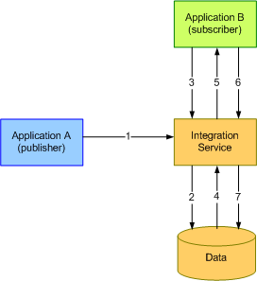
Figure 7: Custom Publish/Subscribe Scenario
- Application A (publisher) sends a message to the Integration Service.
- The Integration Service persists message in a message queue in the custom database.
- Application B (subscriber) sends a request to poll for the message from application A.
- The Integration Service matches the request and retrieves from the custom database.
- The Integration Service sends the message to application B.
- Application B acknowledges asynchronously that it received the message successfully.
- The integration Service moves the message from the queue to “archive”.

The current MwLink service provides such mechanism. However, the functionality needs to be ported to the Integration Service as part of the Service’s roadmap and in order to move the integrations provided by MwLink to the Integration Service.

In order to port the above functionality from MwLink, the following components have to be developed in the Integration Service:

- Database structure to hold messages
- SQL Adapter Schemas.
- Configuration Sections.
- Exception Handling

The following sub-sections describe the design details for the above components.

Database Structure
The following figure illustrates the existing database structure required for the mechanism:

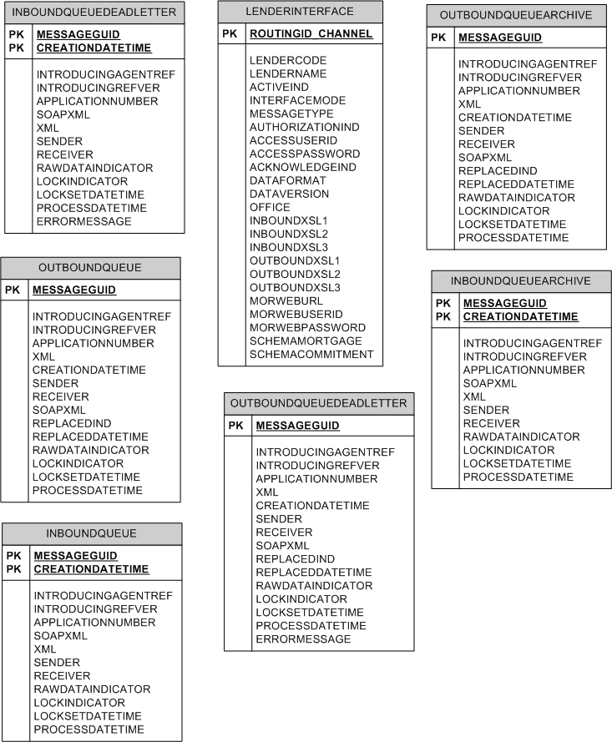
Figure 8: Custom Publish/Subscribe Database Structure

To manage the transactions, the following existing stored procedure will be ported from MwLink with minor modifications:

- USP_CreateInboundMessage
- USP_CreateOrUpdateOutboundMessage
- USP_GetApplicationInfo
- USP_GetFirstOutboundUnlockedMessage
- USP_LockAndGetFirstUnlockedInboundMessage
- USP_LockAndGetFirstUnlockedOutboundMessage
- USP_MoveInboundMessage
- USP_MoveInboundMessageToDeadLetterQueue
- USP_MoveOutboundMessage
- USP_MoveOutboundMessageToDeadLetterQueue
- USP_RecoverInboundMessage
- USP_RecoverOutboundMessage
- USP_UnlockInboundMessage
- USP_UnlockInboundOverdueMessages
- USP_UnlockOutboundOverdueMessages
- USP_UpdateInboundMessageForXML
- USP_ UpdateOutboundMessageForXML
- USP_ValidateRoutingChannel

The specifications for these stored procedures are documented in MwLink specific document.

SQL Adapter Schemas

In order to update the database with messages, BizTalk SQL adapters would be used. The schemas for adapters contain database insert/update/delete statement information in the form of “updategram” or stored procedure information along with required parameters. The schemas are generated using a schema generating wizard within Visual Studio 2005.

When an internal or external system publishes a message to the custom database, a SQL adapter is used to insert the message into table “OutboundQueue” using stored procedure USP_CreateOrUpdateOutboundMessage. The parameters for this stored procedure are as follows:
- Routingid_channel
- Introducingagentref
- Introducingrefver
- Applicationnumber
- Xml
- Sender
- Replaceoutboundmessage

When the schema generating wizard is used against this stored procedure, the resulting schema contains the above parameters as elements, to which the values are mapped from incoming message. Call this schema “MSCISQueuePublisher.xsd”. The incoming message schema is the Integration Service specific schema, that is CDI schema as described in the previous chapters of this document. Using the CDI schema as source and the new SQL adapter specific schema generated above as destination, a BisTalk map is created while mapping the values. This transformation is used for the incoming message to update the database. This would publish the message destined for the system as specified in the “routingid_channel” value in the above schema.

Once the message is published for a given subscriber (routing id or channel), that is a specific recipient as indicated in the routingid_channel field value, it is available for subscription. When a subscriber or recipient is ready to consume a message, it would send a request to the Integration Service, identifying itself using CDI schema message. The schema contains information such as source and provider. The value for CDI’s source field is the same as routingid_channel field in this database. When a request is received for subscription, a SQL adapter is used to retrieve data from the database using a stored procedure USP_LockAndGetFirstUnlockedOutboundMessage. The parameters for this procedure is the routingid_ channel. A schema is created to instruct the BizTalk SQL adapter to use this procedure along with the parameter. Call this schema “MSCISQueueSubscriber.xsd”. At run time, the incoming message is transformed to this schema using a map that maps CDI’s source value to the above parameter.

Each message published must have a unique message id. This message id is used to correlate when the subscriber acknowledges that it subscribed the message successfully. When a recipient acknowledges asynchrnously with a message that contain the message id, a SQL adapter is used to run stored procedure “USP_MoveOutboundMessage” to move the message from OutboundQueue table to OutboundQueueArchive table. A SQL adapter schema is generated to accomplish this task. Call this schema “MSCISMessageArchive.xsd”.

Configuration Sections

As discussed in chapter 2, configuration sections provide message level properties and information such as provider, serviceType, and associated recipient list etc. Based on these properties, message is dynamically routed to a recipient using filters on send port within BizTalk application.

The following configuration sections are needed to route the messages to and from the custom database:

<configSections>
<section name="MSCISLink" type="MSC.IntegrationService.ConfigService.MessageConfig,MSC.IntegrationService.ConfigService, Version=1.0.0.0, Culture=neutral, PublicKeyToken=4615c854f35b0036"/>
</configSections>
<MSCISLink description="" type="provider" debug="">
<serviceTypeList>
<serviceType name="PublishMsg" direction="inbound"
aggregateResponse="false">
<recipientList>
<recipient name="MSCISPub" url="" userId=""
password="" protocol="" assembly="" operation=""
operationType="sync|async"
recipientDomain="internal|external"
requestMapType="" responseMapType="" />
</recipientList>
</serviceType>
<serviceType name="Subscribe[[clientname]]Msg"
direction="inbound" aggregateResponse="false">
<recipientList>
<recipient name="MSCISSub" url="" userId=""
password="" protocol="" assembly="" operation=""
operationType="sync|async"
recipientDomain="internal|external"
requestMapType="" responseMapType="" />
</recipientList>
</serviceType>
<serviceType name="AcknowledgeMsg" direction="inbound"
aggregateResponse="false">
<recipientList>
<recipient name="MSCISAck" url="" userId=""
password="" protocol="" assembly="" operation=""
operationType="sync|async"
recipientDomain="internal|external"
requestMapType="" responseMapType="" />
</recipientList>
</serviceType>

</serviceTypeList>
</MSCISLink >

Three SQL adapter send ports are setup with filters on provider and recipient name only to route the messages.

When a message is published, the message is stored in the custom database in the original message format without any transformation. However, when the message is subscribed, it could be transformed to subscriber specific format using mapping information provided in “responseMapType” in the above configuration section. Note that the serviceType name for the subscription service includes subscriber id. This would enable us to include subscriber specific transformation when sending message back to subscriber. Note that as there could be multiple serviceTypes with different subscriber name in it, there is no need to use this field in send port filter.

Exception Handling

When an exception occurs, the message should be persisted and the technical staff needs to be alerted. In BizTalk orchestration, exceptions are handled using atomic scope. When the exception is caught, the original message is persisted into the custom database table “DeadLetterQueue” using a store procedure. This is achieved using a one-way static SQL adapter port. The SQL adapter schema is built using the original message and the error message.

Auditing
MSC may have contractual obligation to keep messages that are exchanged between the integrating parties for various reasons such as auditing, trouble shooting error scenarios, etc. For these reasons, the Integration Service is required to provide functionality to persist original message intended for a recipient along with the transformed message which is recipient specific format.

In order to persist the messages for audit purposes, the following components are required:

- Custom database table
- Orchestration
- SQL adapter send port

Database Table

The table structure is as follows:

MSCISAudit
MessageId PK, int, identity
CreateDateTime Datetime, Not null
RequestId varchar(20), Not null
Source varchar(20), Not null
Provider varchar(20), Not null
Recipient varchar(20), Not null
ServiceType varchar(20), Not null
SourceMessage ntext, null
RecipientMessage ntext, null

Orchestration
In the orchestration, the audit message is persisted after the call to the original recipient is made and response is consumed as shown in the diagram below:

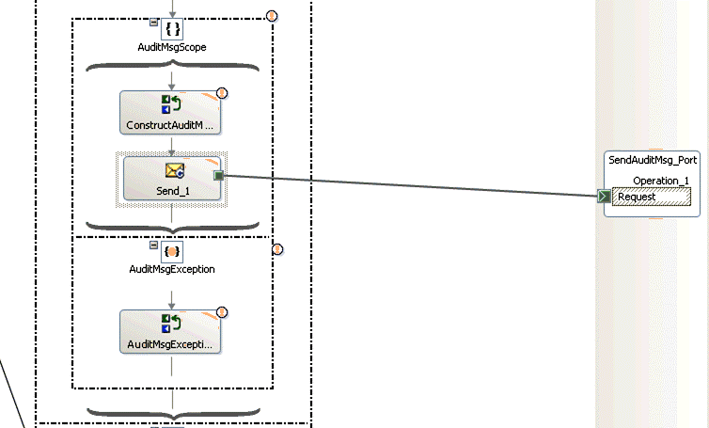

Figure 9: Audit Message Orchestration
The send message shape for the audit message is placed in an atomic scope. This will enable us to catch exceptions that may occur during updates to database. This exception should not interfere with the original message orchestration from the requester. The exception is handled and the process to respond to the original message is continued.

Within the atomic scope, an Expression shape is used to construct audit message using a schema for SQL adapter as a destination and original CDI schema as source. Once the message is constructed with required field values, an Xpath expression is used to set recipient related transformed message into the audit message for field “RecipientMessage”. The message is sent to database via a one-way port which will be bound to SQL adapter in BizTalk administrator. If an exception occurs during update, it is handled in the catch block of the atomic scope, and the original orchestration is continued.

SQL adapter send port
A SQL adapter send port is set up in the BizTalk administrator for the above logical port shown in the diagram. This adapter is used to update database table MSCISAudit with every message coming into the Integration Service.

Recipient List Pattern
One of the design decisions for the Integration Service is to provide messaging to multiple recipients for a given service. For example, a message is intended for a service provided by one particular provider is also required by one or more other recipients, then this message should be sent to all of the recipients. This functionality can be achieved using ‘recipient list’ pattern. At a later stage this pattern can also be leveraged for implementing ‘response aggregation’ from multiple recipients. The following diagram illustrates this pattern.

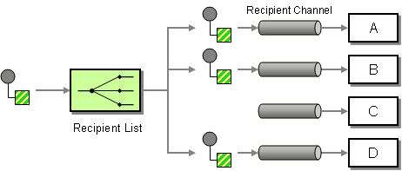

Figure 10: Recipient List Pattern

This design decision also reflects in the configuration section. The configuration section includes a recipientList node under serviceType node. The notion behind this list is that at runtime, the orchestration would go through this list and send messages to all recipients and represents the ‘Recipient List’ as shown in the above diagram.

To facilitate implemention of this pattern in BizTalk, a ‘loop’ shape is used as shown in the figure below.

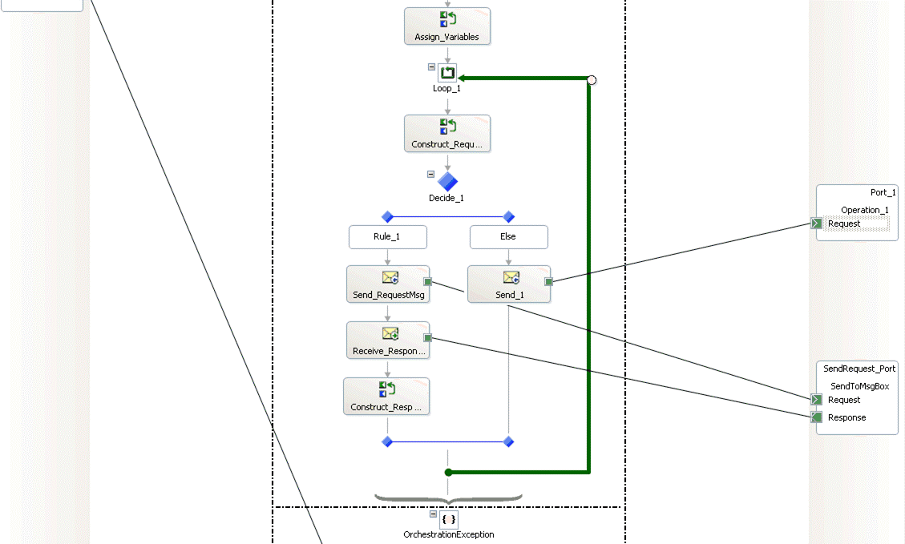
Figure 11: Recipient List Implementation

As shown in the loop expression, the list is consumed using ServiceType.RecipientList.Count expression. For each recipient in the list, message is constructed based on the transformation information and sent to the message box. In the Construct_Request expression, the ‘recipient’ promoted property is updated from the configuration, using the following expression:
requestMessage(MSC.IntegrationService.Schemas.PropertySchema.recipient) = ServiceType.RecipientList[recipientIndex].Name;

Also, Recipient object instance is created using:
Recipient = ServiceType.RecipientList.GetRecipient(recipientIndex);

Once the recipient promoted property is assigned, this property is used in the send port filter so that the port can subscribe to the message and send it to the corresponding recipient.

When a message is sent to recipient, the operation type could be synchronous, asynchronous or fire-and-forget type. A two way branch is implemented to separate different types of operations. Asynchronous and fire-and-forget types are send to message box via one-way logical port while synchronous messages are sent via request-response logical port. For synchronous operations, response is immediate and hence the expression shape to capture response is within the left hand side branch in the above figure. For other types, there will not be any response and hence the process continues through to the next recipient in the list.

Please note that the design decision at this stage is that the response from the intermediary recipients with operation type synchronous will not be processed. However the response from the final recipient in the list will be processed and sent back to the caller as the response. The response from the intermediary recipients can be consumed when ‘Aggregator’ pattern is implemented at a later stage.

In order to capture only the response from recipient that the original message is intended for, check the current recipient in the loop against the recipient name in the original message in CDI schema. If it matches, capture the response and send it to the caller. This is done in the Construct_ResponseMsg shape in the above diagram.

BizTalk Performance Settings
As more and more integrations are added to the Integration Service, it becomes increasingly important that the performance of messaging through the service is sustained. The following performance related settings are required to be implemented.

CLR Hosting Thread Values for the Host
Because a Windows thread is the most basic executable unit available to a Windows process it is important to allocate enough threads to the .NET thread pool associated with an instance of a BizTalk host to prevent thread starvation. When thread starvation occurs there are not enough threads available to perform the requested work which negatively impacts performance. At the same time, care should be taken to prevent allocating more threads to the.NET thread pool associated with a host than is necessary. The allocation of too many threads to the.NET thread pool associated with a host may increase context switching. Context switching occurs when the Windows kernel switches from running one thread to a different thread which incurs a performance cost. Excessive thread allocation can cause excessive context switching which will negatively impact overall performance.

Modify the number of Windows threads available in the .NET thread pool associated with an instance of a BizTalk host by creating the appropriate CLR Hosting values in the registry of the BizTalk Server.

Worker threads are used to handle queued work items and I/O threads are dedicated callback threads associated with an I/O completion port to handle a completed asynchronous I/O request. Set the following settings in the registry under HKEY_LOCAL_MACHINE\SYSTEM\CurrentControlSet\Services\BTSSvc$hostname]\CLR Hosting, where hostname is the name of the host associated with the host instance. Restart the host once updated.

DWORD entry | Default value | Recommended value
MaxIOThreads | 20 | 100
MaxWorkerThreads | 25 | 100
MinIOThreads | 1 | 25
MinWorkerThreads | 1 | 25

HTTP and SOAP Adapter Performance
The following settings can be applied to an ASP.NET application that hosts a web application that the HTTP or SOAP adapter communicates with. These parameters are set in the web.config or machine.config files of the server hosting the web application. Modify these settings to accommodate the load that is generated by your HTTP or SOAP adapter send port.

Parameter | Section of configuration file | Default value | Recommended value
minFreeThreads  The minimum number of free threads to allow execution of new requests. ASP.NET keeps this many threads free for requests that require additional threads to complete their processing. | <httpRuntime> | 8 | 88 * the number of processors on the server hosting the web application.
minFreeLocalRequestFreeThreads  The minimum number of free threads that ASP.NET keeps available to allow execution of new local requests. This number of threads is kept reserved for requests coming from the local host, in case some requests issue child requests to the local host during their processing. This avoids a possible deadlock with recursive reentry into the Web server. | <httpRuntime> | 4 | 76 * the number of processors on the server hosting the web application.
executionTimeout  Indicates the maximum number of seconds that a request is allowed to execute before being automatically shut down by ASP.NET. | <httpRuntime> | 90 | 90
maxconnection  Determines how many connections can be made to a specific IP address. | <connectionManagement> | 2  A value of 2 for this setting conforms to the IETF RFC for the HTTP 1.1 specification and is suitable for user scenarios but is not optimized for high throughput. | 12 * the number of processors on the server hosting the web application.
maxWorkerThreads  Configures the maximum amount of worker threads to be used for the process on a per-CPU basis. | <processModel> | 20 | 100  This value is implicilty multiplied by the number of processors on the server
minWorkerThreads | <processModel> | 1 | maxWorkerThreads / 2  This value is implicilty multiplied by the number of processors on the server.  This value is implicilty multiplied by the number of processors on the server.
maxIoThreads  Used by ASP.NET to limit the number completion threads used. | <processModel> | 20 | 100  This value is implicilty multiplied by the number of processors on the server.

APPENDIX A – CDI Schema
<?xml version="1.0" encoding="utf-16" ?>
- <xs:schema xmlns:b="http://schemas.microsoft.com/BizTalk/2003" attributeFormDefault="unqualified" elementFormDefault="qualified" targetNamespace="http://mscanada.com" xmlns:xs="http://www.w3.org/2001/XMLSchema">
- <xs:element name="clipboard">
- <xs:complexType>
- <xs:sequence>
- <xs:element name="context">
- <xs:complexType>
<xs:attribute name="applicationName" type="xs:string" use="required" />
<xs:attribute name="sessionId" type="xs:string" use="required" />
<xs:attribute name="userid" type="xs:string" use="required" />
<xs:attribute name="language" type="xs:string" use="required" />
<xs:attribute name="dateTime" type="xs:string" use="required" />
</xs:complexType>
</xs:element>
- <xs:element name="request">
- <xs:complexType>
- <xs:sequence>
<xs:element name="comment" type="xs:anyType" />
- <xs:element name="errors">
- <xs:complexType>
- <xs:sequence>
- <xs:element name="error">
- <xs:complexType>
<xs:attribute name="code" type="xs:string" use="required" />
<xs:attribute name="message" type="xs:string" use="required" />
</xs:complexType>
</xs:element>
</xs:sequence>
</xs:complexType>
</xs:element>
</xs:sequence>
<xs:attribute name="requestId" type="xs:string" use="required" />
<xs:attribute name="serviceType" type="xs:string" use="required" />
<xs:attribute name="source" type="xs:string" use="required" />
<xs:attribute name="provider" type="xs:string" use="required" />
</xs:complexType>
</xs:element>
<xs:element minOccurs="0" maxOccurs="1" name="applicationData" type="xs:anyType" />
</xs:sequence>
</xs:complexType>
</xs:element>
</xs:schema>

Note that the applicationData is of anyType. This is to accommodate different input types while providing a unified messag type from the Integration service view point.

